Oppgave 4a)

Magnitude respons

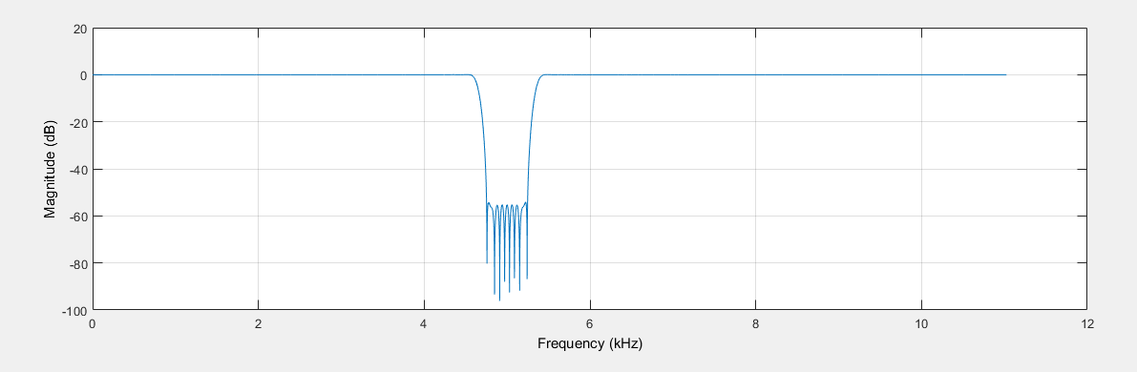

Passband magnitude response

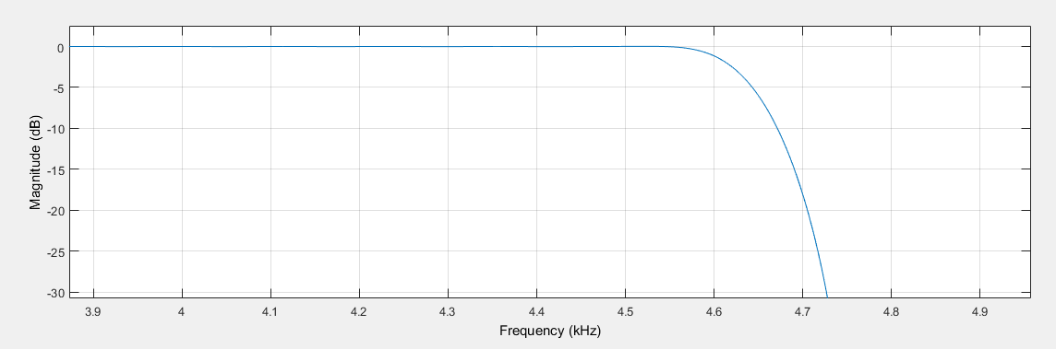

Phase response

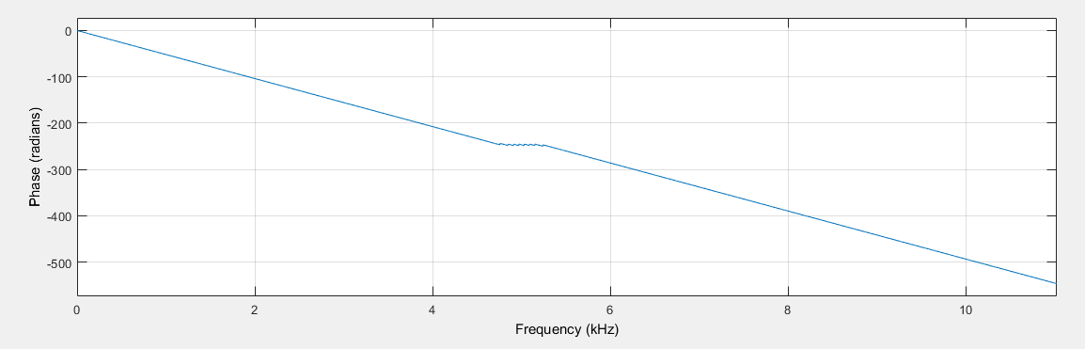

Oppgave 4b)

Magnitude respons

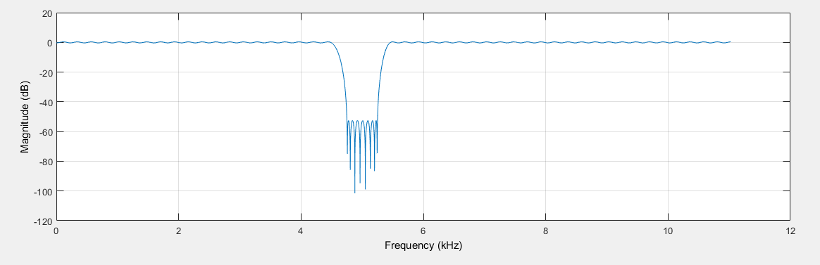

Passband magnitude response

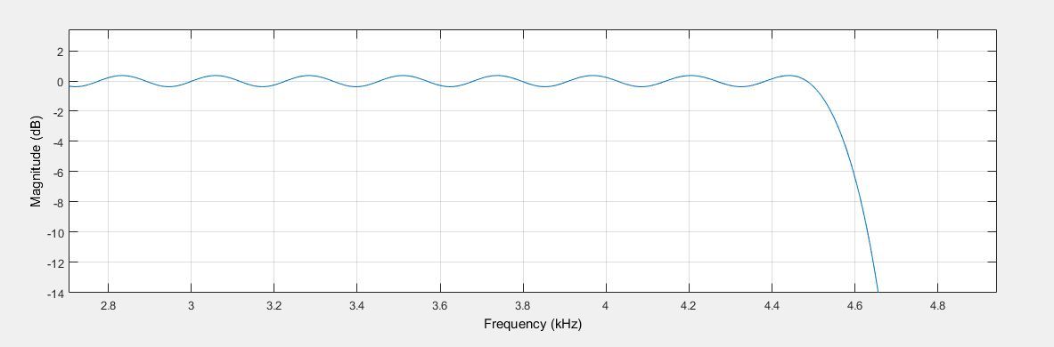

Phase response

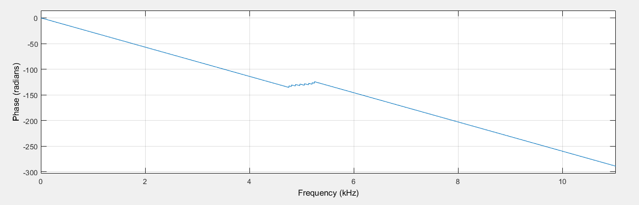

Oppgave 4c)

Magnitude respons

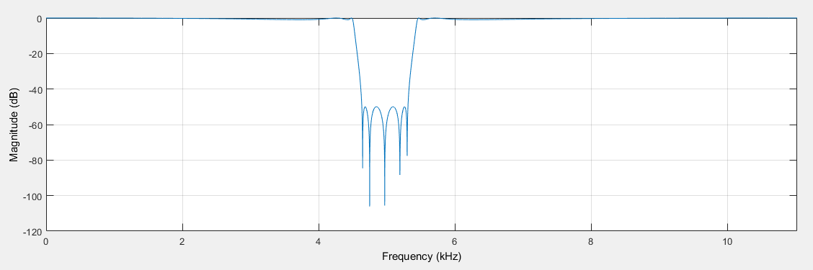

Passband magnitude response

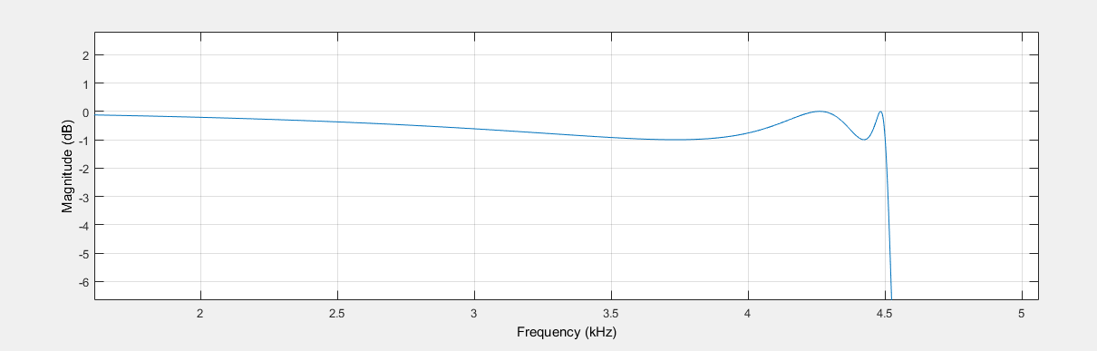

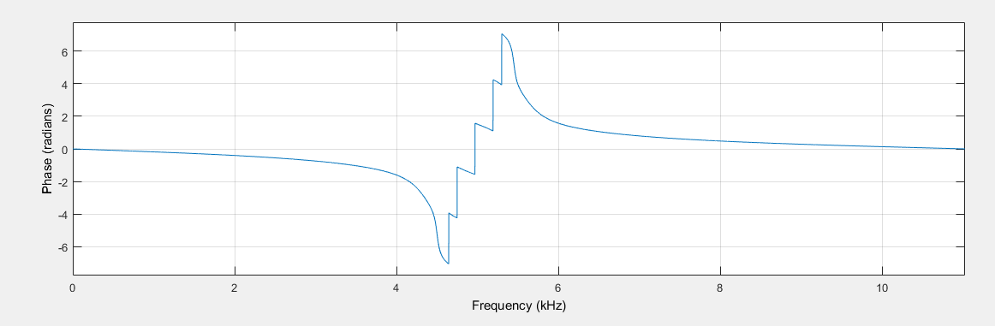Phase response